Final Project Report

ToyLand



Project Supervisor
Neelam Alam

Submitted By

F21020F57E(MC160401595)

Software Projects & Research Section,
Department of Computer Sciences,
Virtual University of Pakistan


CERTIFICATE

This is to certify that <<First Member Name>> (<<VU ID>>), <<Second Member Name>> (<<VU ID>>) have worked on and completed their Software Project at Software & Research Projects Section, Department of Computer Sciences, Virtual University of Pakistan in partial fulfillment of the requirement for the degree of BS in Computer Sciences under my guidance and supervision.

In our opinion, it is satisfactory and up to the mark and therefore fulfills the requirements of BS in Computer Sciences.

Supervisor / Internal Examiner

<<Project Supervisor Name>>
Supervisor,
Software Projects & Research Section,
Department of Computer Sciences
Virtual University of Pakistan

___________________
(Signature)

External Examiner/Subject Specialist
<<External Supervisor Name>>

___________________
(Signature)

Accepted By:

_____________
(For office use)

EXORDIUM

In the name of Allah, the Compassionate, the Merciful.

Praise be to Allah, Lord of Creation,
The Compassionate, the Merciful,
King of Judgment-day!

You alone we worship, and to You alone we pray for help,
Guide us to the straight path

The path of those who You have favored,

Not of those who have incurred Your wrath,
Nor of those who have gone astray.

DEDICATION

I would like to express my gratitude towards my parents & member of Virtual University for their kind co-operation and encouragement which help me in completion of this project. I would like to express my special gratitude and thanks to friends and teachers for giving me such attention and time.

ACKNOWLEDGEMENT

I have taken efforts in this project. However, it would not have been possible without the kind support and help of many individuals and organizations. I would like to extend my sincere thanks to all of them.

PREFACE

Toyland is a toy website for kids. The toys are the important part of kids life. Kids like to play with toys. Every kid like to shop toys of their choice. In the current situation of COVID it is risky for kids to go in the markets without masks to buy toys.

So we are developing the toy land it is e-commerce website where user can buy the kid toys online by watching toy products images, video , description and other detail.

This website has a toy for kids of each age group, and category etc. this website will show the kid toys and toy details. the user can place their kid order online and pay the payment online or cash on delivery. The user can add toy product to the cart and place order. The user can even track the order view the summary of the order.

This website helps the user to search and sort toy product according to their choice, this website will also learn the use of applications and their capabilities to search, select and decide will also be improved.

TABLE OF CONTENTS

CHAPTER NO. 1
gathering & Analyzing info 9

1.1 Introduction

1.2 purpose

1.3 scope

1.4 definitions, acronyms and abbreviations

1.5 use cases and usage scenarios

1.5.1 Use Case Diagrams

1.5.2 Usage Scenarios

1.6 supplementary requirements

1.6.1 Usability

1.6.2 Reliability

1.6.3 Supportability

1.6.4 System Requirements

CHAPTER NO. 2
planning the project 26
2.1 Introduction

2.2 Methodology

  - Available Methodologies

  - Chosen Methodology

  - Reasons for Chosen Methodology

  - Work Plan
  - Project Structure

    - Team Structure

    - Project Schedule (Submission Calendar)

CHAPTER NO. 3
designing the project 32

3.1 Introduction

3.2 purpose

3.3 scope

  - definitions, acronyms and abbreviations

  - Architectural Representation (Architecture Diagram)

  - Dynamic Model: Sequence Diagrams

  - Object Model/Logical Model: Class Diagram

  - Database Model (Database Diagram)

  - Graphical User Interfaces

Chapter no.4
DEvelopment 51
4.1 Development plan (Architecture Diagram)

CHAPTER 1
Gathering & Analyzing Info

  - Introduction

Toyland is a toy website for kids. The toys are the important part of kids life. Kids like to play with toys. Every kid like to shop toys of their choice. In the current situation of COVID it is risky for kids to go in the markets without masks to buy toys.

So we are developing the toy land it is e-commerce website where user can buy the kid toys online by watching toy products images, video , description and other detail.

This website has a toy for kids of each age group, and category etc. this website will show the kid toys and toy details. the user can place their kid order online and pay the payment online or cash on delivery. The user can add toy product to the cart and place order. The user can even track the order view the summary of the order.

This website helps the user to search and sort toy product according to their choice, this website will also learn the use of applications and their capabilities to search, select and decide will also be improved.

  - purpose

Toyland make it safe to buy kid toys from market, the user can easily buy the kid toys online. The user can use this website at anytime and anywhere,
This website provides the secure way for kids or people to buy toys online. So the main purpose of the website is to buy secure and easy way to buy toys online .

1.3 scopes

This system has a scope because it can be used in market place for the people who have the kids toy shop or business where people can easily approach the toys online and the owner of the system can grow their business. The system is developed in English which will be easily understood by the people.

Functional and non-Functional Requirements:

Functional Requirements:

1 Functional Requirements:

1. Home page of website should have a professional website like interface with attractive items having following sequence:
I) Title and related image on top.
II) A sort option (on the basis of age group, Product type, Price).
III) Search, tracking order and cart images having their web pages links should be there.

2. Create, Register, Approval or rejection of registration and login pages to add Admin, customers’ record in data base with fields (Username, Password, Email Id, Contact No, and Address).

3. Customer can order product in two ways:
I) As a member by logging in his/her account
II) He/She can directly order items as guest.

4. Menu bar should contain tabs having toys types like 3D Puzzles, Learning Toys, Baby Teethers, Musical Toys, Baby Crib Toys, Baby Push Toys, Baby Rattles, Baby Blocks Toys, and Stuffed Toys.

5. By clicking on a toy type tab, it leads to a next webpage having all items of this category.
I) Above page should contain a proper name of toy, its price, demo video and drop down to select “Quantity”. There must be an “Add to Cart” button to put selected items in cart.
II) The description of item should contain the fields like. No of items in a set: Material: Size: Color:

6. By clicking on cart, a list should be visible for selected items and their quantity, price, delivery fee, and total amount. There should be a quantity increment or decrement button and a remove button against each item.

I. Continue Shopping, Update, and Check Out buttons should be there at the end of cart.
II. Payment methods (Pay viva Visa card, Cash on delivery) must also be shown using radio buttons. III. Confirm order and show summary of order with successful message when customer click on confirmation

Non-functional Requirements:

- Usability: Usability of software will be easy so that e-learner can use it without any difficulty.
- Maintainability: Software would build up in such a way that classifications of errors and maintenance of mechanism become easy.
- Flexibility: Software would be flexible so that it can easily accept all changes at low cost, time and experience.
- Security: Software will be secure. No one can use this application without a registered username and password.
- Reliability: The System will support 7 X 24 operations.
- Performance: Application should be designed and developed in such a way that it should not utilize too many resources

  - definitions, acronyms and abbreviations

CSS Cascading Style Sheets: Without CSS, the web would be a lot more boring. CSS is a language of rules that affect the style of HTML content. When a website uses consistent colors, fonts, and layouts across multiple web pages, this was accomplished with CSS. It’s like the icing on top of a cake built with HTML.

HTML Hypertext Markup Language: This is the first part of front-end development that many people know the basics of. Even if you aren’t technical, you may have used HTML to edit an email layout or change the text on a web page.

CRUD Create, Read, Update, Delete: If someone is learning how to build a CRUD app, they aren’t learning how to build a terrible one. They’re learning how to build an app that completes these four basic functions.

PHP Originally Personal Home Page, but renamed to PHP Hypertext Preprocessor: PHP is a common free and open-source script language used in web development.

1.5 use cases and usage scenarios

1.5.1 Use Case Diagrams

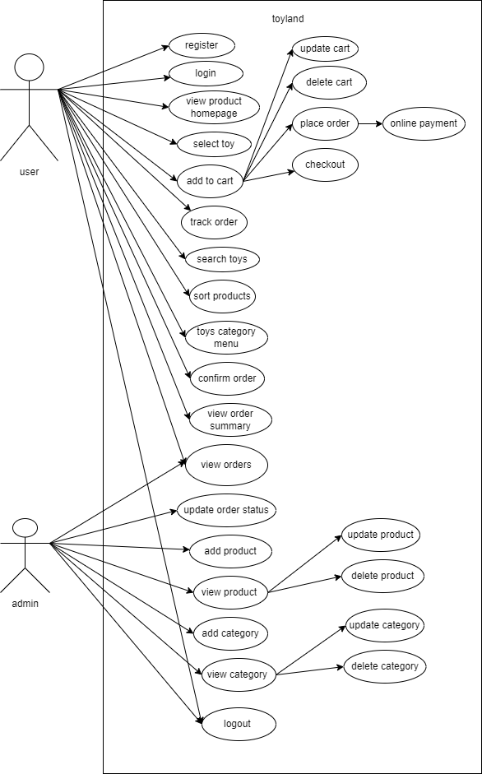

1.5.2 Usage Scenarios

Usage scenarios 1:

Use case title | Register
Abbreviated title
Use case ID | 1
Actors | user
Description | In this use case the user can register in the website application by selection the register option.
Pre-conditions | Internet connection should be available and user open the website.
Task sequence |  |  | Exceptions
1. The user must open the website  2. The user must select the register option to register himself in the website and the user account will be created. |  |  | 1. The system will create the user account and save the user account details in the database.  2. If any error comes up in registration process it informs the user.
Post condition |  | user has successfully registered in the application and user account has been created.
Author |  | Mc160401595

Usage scenarios 2:

Use case title | login
Abbreviated title
Use case ID | 2
Actors | User/admin
Description | In this use case the actor can login in the website application by selection the login option.
Pre-conditions | Internet connection should be available and actor open the website and register first in the website.
Task sequence |  |  | Exceptions
The actor can login in its account by selecting login option |  |  | The system will check the data from the database if actor account exist in the database the system will let the actor login in its account otherwise if notify no account exist.
Post condition |  | user has successfully login in the website.
Author |  | Mc160401595

Usage scenarios 3:

Use case title | View toy product homepage
Abbreviated title
Use case ID | 3
Actors | user
Description | In this use case the user can view the toy products on the homepage. The homepage display all the product detail like image title price etc.
Pre-conditions | Internet connection should be available and user open the website.
Task sequence |  |  | Exceptions
The user can view any toy product on the homepage with product detail. |  |  | The system will fetch all the product detail from the database and show it.
Post condition |  | user has successfully view the products on the homepage.
Author |  | Mc160401595

Usage scenarios 4:

Use case title | Select toy product
Abbreviated title
Use case ID | 4
Actors | user
Description | In this use case the user can select any of the product
Pre-conditions | Internet connection should be available and user open the website.
Task sequence |  |  | Exceptions
The user can select any product from the product |  |  | The system will select the user product
Post condition |  | user has successfully select the product.
Author |  | Mc160401595

Usage scenarios 5:

Use case title | Add to cart
Abbreviated title
Use case ID | 5
Actors | user
Description | In this use case the user can add the select product to the cart
Pre-conditions | Internet connection should be available and user open the website.
Task sequence |  |  | Exceptions
The user can add the selected product to the cart. |  |  | The system will add the user selected product in the user product session and show it
Post condition |  | user has successfully add product to the cart
Author |  | Mc160401595

Usage scenarios 6:

Use case title | Update cart
Abbreviated title
Use case ID | 6
Actors | user
Description | In this use case the user can update the cart products
Pre-conditions | Internet connection should be available and user open the website.
Task sequence |  |  | Exceptions
The user can update the cart the product qty etc. |  |  | The system will update the cart session details.
Post condition |  | user has successfully update the cart
Author |  | Mc160401595

Usage scenarios 7:

Use case title | delete cart
Abbreviated title
Use case ID | 7
Actors | user
Description | In this use case the user can delete any product from the cart
Pre-conditions | Internet connection should be available and user open the website.
Task sequence |  |  | Exceptions
The user can delete any product from the cart |  |  | The system will delete selected product from the cart session
Post condition |  | user has successfully delete the product from the cart
Author |  | Mc160401595

Usage scenarios 8:

Use case title | Place order
Abbreviated title
Use case ID | 8
Actors | user
Description | In this use case the user can place the order
Pre-conditions | Internet connection should be available and user open the website.
Task sequence |  |  | Exceptions
The user can place the order online by adding all order details and select the payment mode. |  |  | The system will check all the place order details
Post condition |  | user has successfully place order
Author |  | Mc160401595

Usage scenarios 9:

Use case title | checkout
Abbreviated title
Use case ID | 9
Actors | user
Description | In this use case the user can checkout the order
Pre-conditions | Internet connection should be available and user open the website.
Task sequence |  |  | Exceptions
The user can checkout after placing order. |  |  | The system will save the user order and checkout details in the database.
Post condition |  | user has successfully checkout the order
Author |  | Mc160401595

Usage scenarios 10:

Use case title | Track order
Abbreviated title
Use case ID | 10
Actors | user
Description | In this use case the user can check the tracking of order after placing order
Pre-conditions | Internet connection should be available and user open the website.
Task sequence |  |  | Exceptions
The user can track its order |  |  | The system will fetch the order status from the database and show it.
Post condition |  | user has successfully checkout the order
Author |  | Mc160401595

Usage scenarios 11:

Use case title | Search toy
Abbreviated title
Use case ID | 11
Actors | user
Description | In this use case the user can search the toys
Pre-conditions | Internet connection should be available and user open the website.
Task sequence |  |  | Exceptions
The user can search the products from the website |  |  | The system will fetch all the products related to product search query and show it
Post condition |  | user has successfully search toy.
Author |  | Mc160401595

Usage scenarios 12:

Use case title | Sort product
Abbreviated title
Use case ID | 12
Actors | user
Description | In this use case the user can sort the product
Pre-conditions | Internet connection should be available and user open the website.
Task sequence |  |  | Exceptions
The user can sort the products by using sort filters of different type price ,category etc |  |  | The system will fetch all the products related to sort filters and show it
Post condition |  | user has successfully sort product
Author |  | Mc160401595

Usage scenarios 13:

Use case title | Toys menu
Abbreviated title
Use case ID | 13
Actors | user
Description | In this use case the user can view the toys product menu
Pre-conditions | Internet connection should be available and user open the website.
Task sequence |  |  | Exceptions
The user can view the toys product category menu by selecting toy menu. |  |  | The system will fetch all the product menu from the database and show it.
Post condition |  | user has successfully view the toys menu.
Author |  | Mc160401595

Usage scenarios 14:

Use case title | Confirm order
Abbreviated title
Use case ID | 14
Actors | user
Description | In this use case the user can confirm order before checkout
Pre-conditions | Internet connection should be available and user open the website.
Task sequence |  |  | Exceptions
The user can confirm order before checkout. |  |  | The system will confirm order and after checkout save the user order details in the database
Post condition |  | user has successfully confirm the order
Author |  | Mc160401595

Usage scenarios 15:

Use case title | View order summary
Abbreviated title
Use case ID | 15
Actors | user
Description | In this use case the user can view the order summary detail of its order
Pre-conditions | Internet connection should be available and user open the website.
Task sequence |  |  | Exceptions
The user can view the order summary detail of its order |  |  | The system will fetch of its order details from the database and show it.
Post condition |  | user has successfully view order summary.
Author |  | Mc160401595

Usage scenarios 16:

Use case title | logout
Abbreviated title
Use case ID | 16
Actors | User/admin
Description | In this use case the user can logout from its account
Pre-conditions | Internet connection should be available and user open the website.
Task sequence |  |  | Exceptions
The actor can logout from its account by selecting logout option |  |  | The system will logout the actor from its account.
Post condition |  | user has successfully logout the actor.
Author |  | Mc160401595

Usage scenarios 17:

Use case title | Add product
Abbreviated title
Use case ID | 17
Actors | admin
Description | In this use case the admin can add the product
Pre-conditions | Internet connection should be available and user open the website.
Task sequence |  |  | Exceptions
The admin can add the product and product details by selecting add product option. |  |  | The system will save the product details in the database.
Post condition |  | Admin has successfully add the product
Author |  | Mc160401595

Usage scenarios 18:

Use case title | View product
Abbreviated title
Use case ID | 18
Actors | admin
Description | In this use case the admin can view all the product
Pre-conditions | Internet connection should be available and user open the website.
Task sequence |  |  | Exceptions
The admin can view all the adding product by selecting the view product option |  |  | The system will fetch all the product details from the database and show it
Post condition |  | Admin has successfully view all the product
Author |  | Mc160401595

Usage scenarios 19:

Use case title | Update product
Abbreviated title
Use case ID | 19
Actors | admin
Description | In this use case the admin can update any selected product
Pre-conditions | Internet connection should be available and user open the website.
Task sequence |  |  | Exceptions
The admin can update any selected product . |  |  | The system will save the new updated data of selected product in the database.
Post condition |  | Admin has successfully update the product
Author |  | Mc160401595

Usage scenarios 20:

Use case title | Delete product
Abbreviated title
Use case ID | 20
Actors | admin
Description | In this use case the admin can delete any selected product
Pre-conditions | Internet connection should be available and user open the website.
Task sequence |  |  | Exceptions
The admin can delete any selected product . |  |  | The system will delete the selected product details from the database.
Post condition |  | Admin has successfully delete the product
Author |  | Mc160401595

Usage scenarios 21:

Use case title | Add category
Abbreviated title
Use case ID | 21
Actors | admin
Description | In this use case the admin can add the product category
Pre-conditions | Internet connection should be available and user open the website.
Task sequence |  |  | Exceptions
The admin can add the product category by selecting add category option. |  |  | The system will save the product category deal in the database.
Post condition |  | Admin has successfully add the product category
Author |  | Mc160401595

Usage scenarios 22:

Use case title | View category
Abbreviated title
Use case ID | 22
Actors | admin
Description | In this use case the admin can view all the category
Pre-conditions | Internet connection should be available and user open the website.
Task sequence |  |  | Exceptions
The admin can view all the adding product category by selecting the view category option |  |  | The system will fetch all the product category from the database and show it
Post condition |  | Admin has successfully view all the category
Author |  | Mc160401595

Usage scenarios 23:

Use case title | Update category
Abbreviated title
Use case ID | 23
Actors | admin
Description | In this use case the admin can update any selected product category
Pre-conditions | Internet connection should be available and user open the website.
Task sequence |  |  | Exceptions
The admin can update any selected category. |  |  | The system will save the new updated data of selected category in the database.
Post condition |  | Admin has successfully update the category
Author |  | Mc160401595

Usage scenarios 24:

Use case title | Delete category
Abbreviated title
Use case ID | 24
Actors | admin
Description | In this use case the admin can delete any selected category
Pre-conditions | Internet connection should be available and user open the website.
Task sequence |  |  | Exceptions
The admin can delete any selected category. |  |  | The system will delete the selected category details from the database.
Post condition |  | Admin has successfully delete the category
Author |  | Mc160401595

Usage scenarios 25:

Use case title | View orders
Abbreviated title
Use case ID | 25
Actors | admin
Description | In this use case the admin can view all the user orders
Pre-conditions | Internet connection should be available and user open the website.
Task sequence |  |  | Exceptions
The admin can view all the orders placed by the user |  |  | The system will fetch all the orders detail from the database and show it
Post condition |  | Admin has successfully view the orders
Author |  | Mc160401595

Usage scenarios 26:

Use case title | Update order status
Abbreviated title
Use case ID | 26
Actors | admin
Description | In this use case the admin can update the status of the order
Pre-conditions | Internet connection should be available and user open the website.
Task sequence |  |  | Exceptions
The admin can update the status of the any selected order . |  |  | The system will save the updated status of the order in the database.
Post condition |  | Admin has successfully update the order status
Author |  | Mc160401595

  - supplementary requirements

1.6.1 Usability: Usability defines how well the application meets the requirements of the user and consumer by being intuitive, easy to localize and globalize, providing good access for disabled users, and resulting in a good overall user experience.

Performance: Application should be designed and developed in such a way that it should not utilize too many resources.

Secure: registration and login system should be safe and secure.

Friendly interface: this app has a friendly interface. Simple and easy to use. The user can easily use it.

Maintain: the app is proper maintain from time to time.

    - Supportability:

System must be accessible from all kind of bowser.

1.6.4 System Requirements

- 64-bit Microsoft® Windows® 8/10.
- x86_64 CPU architecture; 2nd generation Intel Core or newer, or AMD CPU with support for a Windows Hypervisor.
- 8 GB RAM or more.
- 8 GB of available disk space minimum
- 1280 x 800 minimum screen resolution.

CHAPTER 2
Planning the Project

2.1 Introduction:

A project has a lifecycle, underpinned by a plan, which is the path and sequence through the various activities defined to produce its products.
Project management primarily focuses on planning, managing and organizing the available resources. Initiation defines project goals and objectives. · Planning sets out the project scope. · Execution is when the deliverables are created

2.2 Methodology

A methodology is a collection of methods, practices, processes, techniques, procedures and rules. In project management, methodologies are specific, strict and usually contain a series of steps and activities for each phase of the project’s life cycle. They are defined approaches that show us exactly what steps to take next, the motivation behind each step, and how a project stage should be performed.

  - Available Methodologies

The two main methodologies are:
1. Waterfall Model.
2. Spiral Model.

Waterfall Model:

The waterfall model was the first process model to be introduced. It is very simple to understand and use. It is also referred as a linear sequential life cycle model. The waterfall model illustrates the software development in a linear sequential flow. In waterfall model whole software development process is divided into separate phases. This means that any phase in the development process begins only if the previous phase is complete. This model is depicted under the diagram

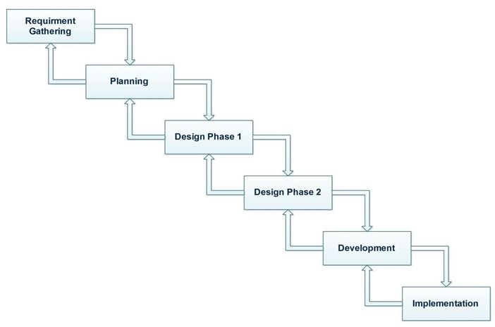

The waterfall Model has a five phases these phases are explain below:

1. Requirements Analysis and definition:

All the requirements of the system is captured in this phase and documented in the requirement specification document.

2. System and software design:

All the requirements gather in the first phase are studied in this phase and design is prepared according to the requirement. This system design helps in specifying hardware and system requirements and defining the overall system architecture.

3. Implementation and unit testing:

From the system design, the system is developed in small programs called units. Each unit is developed and tested for its functionality which is known as unit testing.

4. Integration and System testing:

All the units developed in implementation phase are integrated into a system after testing. In this phase the entire system is tested for any faults and failures.
When the functional and non-functional testing is done, the project is deployed in the customer environment or released into the market.

5. Operation and Maintenance:

If issues come up after the delivery of the project or in the client environment, those issues and errors are fixed in this phase. Maintenance is done to deliver these changes in the customer environment.

Spiral Model :

It is a combination of waterfall model and iterative model.it is a risk driven software development model. It helps to adopt software development elements of multiple process models for the software project based on unique risk patterns ensuring efficient development process.

Each phase of spiral model in software engineering begins with a design goal and ends with the client reviewing the progress. It starts with a small set of requirements and goes through each development phase for those set of requirements. This model is depicted under the diagram

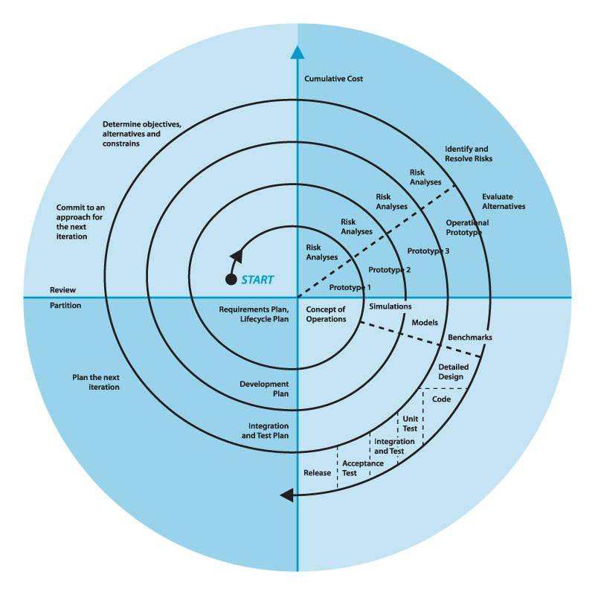
The spiral model has four phases.
1. Planning:
In planning phase it includes estimating the cost, schedule and resources for the iteration. It also involves understanding the system requirements for continuous communication between the system analyst and the customer.
2. Risk Analysis:
Identification of potential risk is done while risk mitigation strategy is planned and finalized.

3. Engineering:
It includes testing, coding and deploying software at the customer site.

4. Evaluation:
Evaluation of the software by the customer. Also, includes identifying and monitoring risks such as schedule slippage and cost overrun.

  - Chosen Methodology
VU Process Model:

Vu process is a combination of waterfall and spiral model. It is also called Hybrid approach of system development. It minimizes risks and errors and maximizes the quality of system. It has five phases which are:
- Analyzing Requirement phase
- Design phase
- Implementation
- Integration and testing phase
- Maintenance and operation

Vu process model diagram:
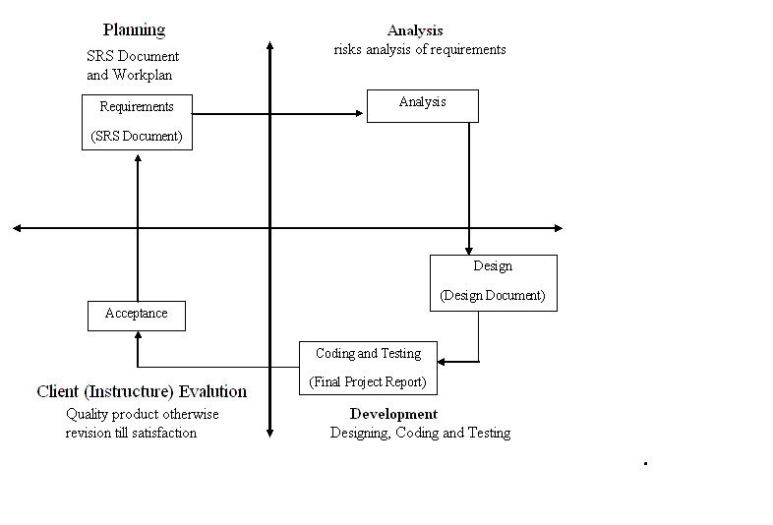

  - Reasons for Chosen Methodology

Following are the reasons for choosing VU process model:

- Vu process model is easy to use and helpful for my project.
- It is a combination of two models spiral and waterfall so get the advantages of both the model.
- All the activities are performed in a sequence.
- It is sequential model with backward repetition.
- Project is divided into many phases. So in vu process model we will work in phases to complete the given model.
- It is error free result as each step is done in a sequence.
- If errors or mistakes are found, it suggests correcting the error or mistake and improving the project.

  - Work Plan

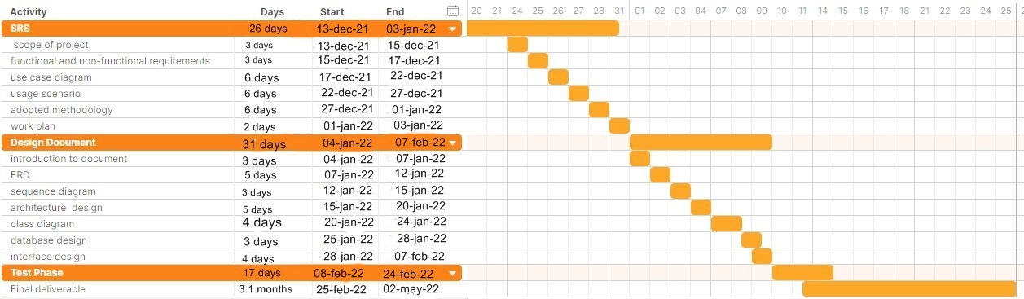

CHAPTER 3
Designing the Project

3.1 Introduction

The Software Design Document is a document to provide documentation which will be used later in software development by providing the details for how the software should be built.

Within the Software Design Document are narrative and graphical documentation of the software design for the project including use Entity Relationship Diagram (ERD), Sequence, Diagrams, Architecture Design Diagram, Class diagram, Database Design, Interface Design and Test Cases.

3.2 purpose

The purpose of the Software Design Document is to provide a description of the design of a system fully enough to allow for software development to proceed with an understanding of what is to be built and how it is expected to build. The Software Design Document provides information necessary to provide description of the details for the software and system to be built.

3.3 scope

There are many benefits of a well-defined design document some of those are:
User’s expectation of the system is documented properly and helps a lot later while developing the site. All major design issues are discussed. Different analysis on the system can be performed. It saves a lot of time of the developer when all the functionality of the system is captured properly and is documented in a file.

3.5 Architectural Representation (Architecture Diagram)
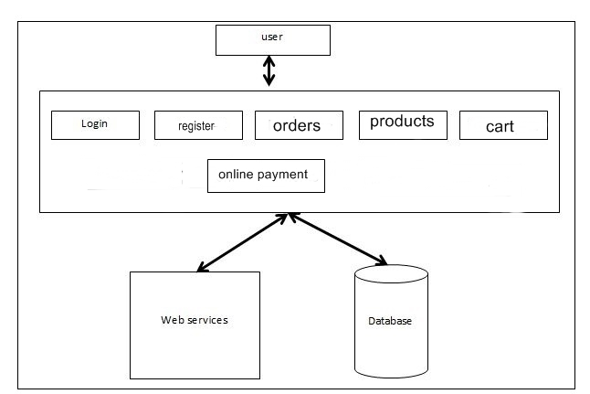

3.6 Dynamic Model: Sequence Diagrams

- Sequence Diagrams
1. register
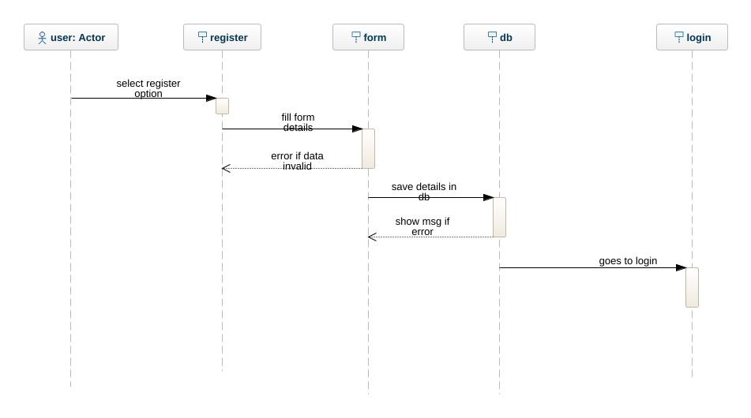
2. login
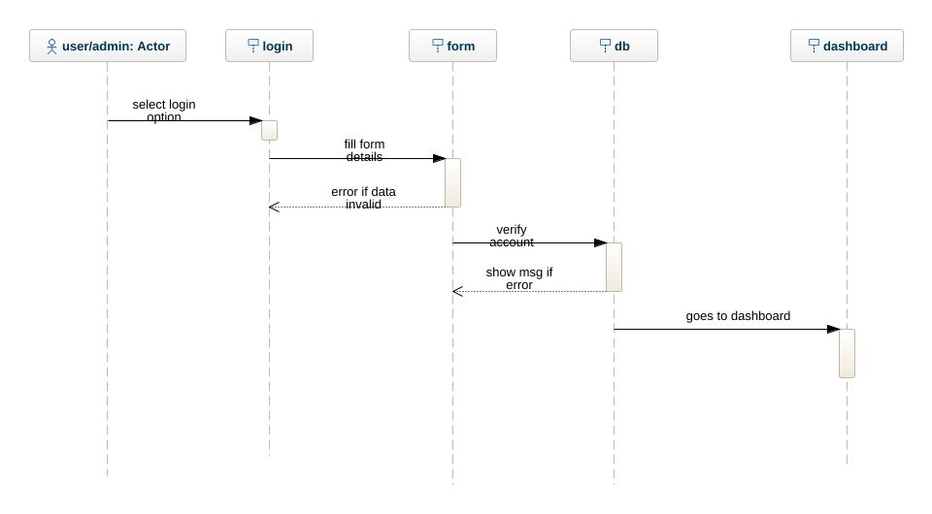

3. view product
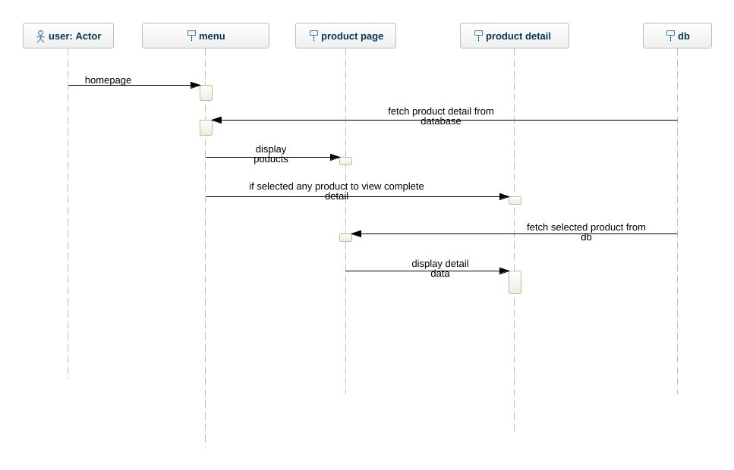
4. select product
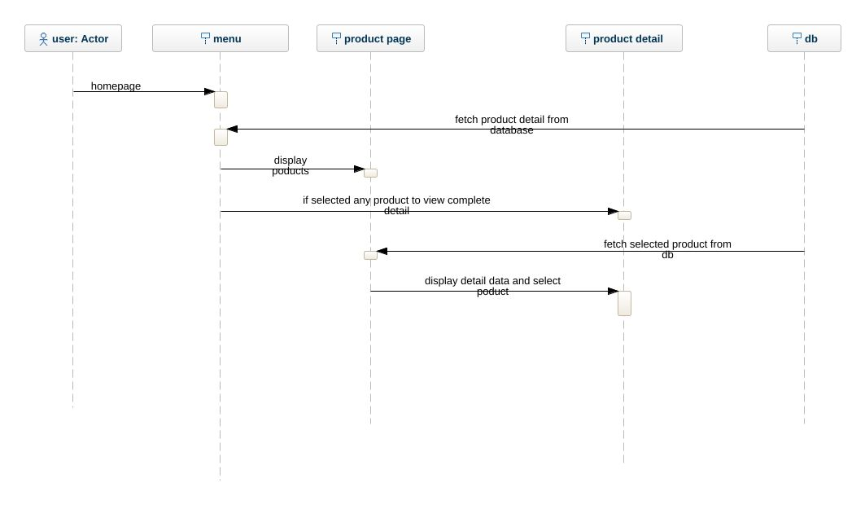

5. add to cart
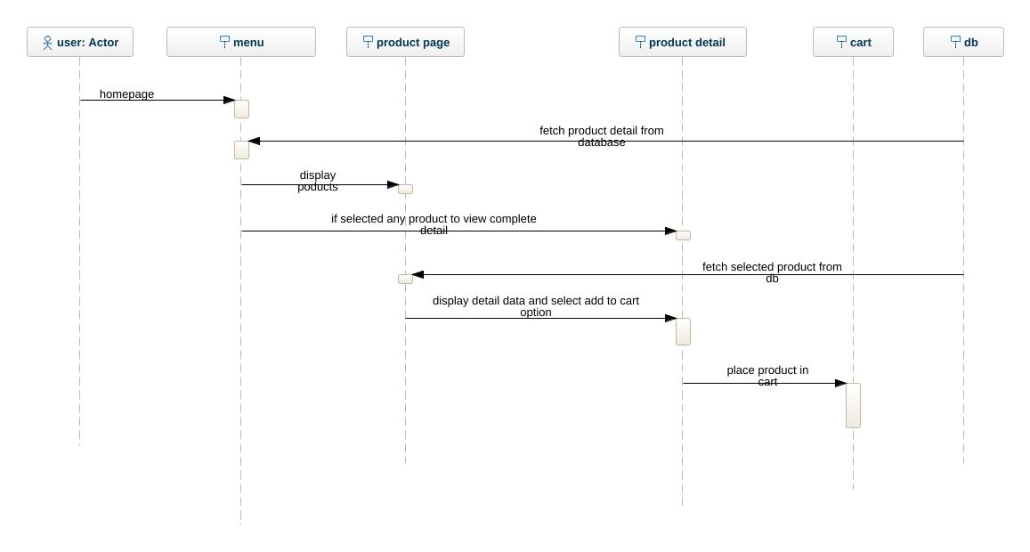
6. place order
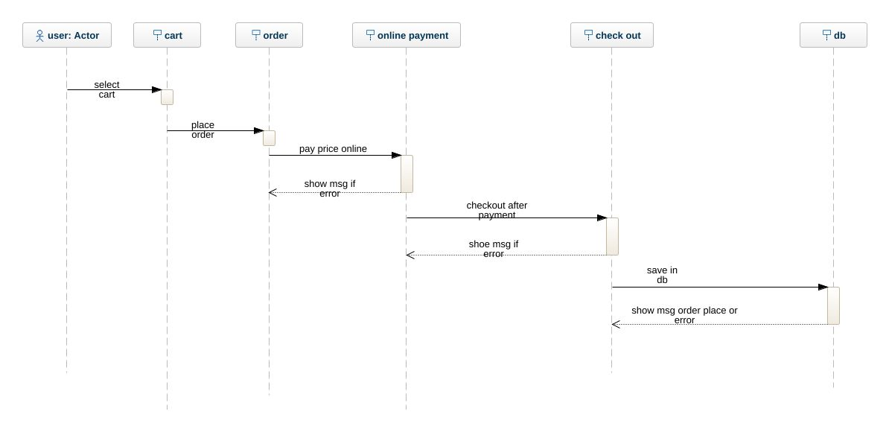
7. track order
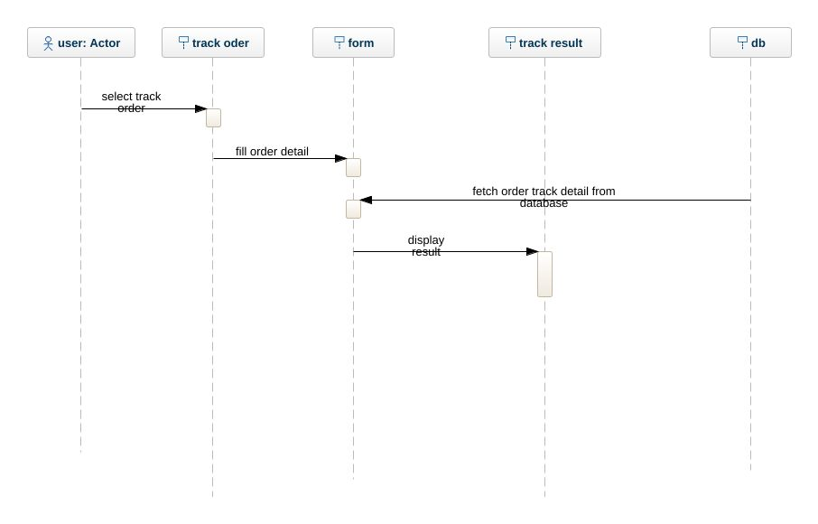
8. logout
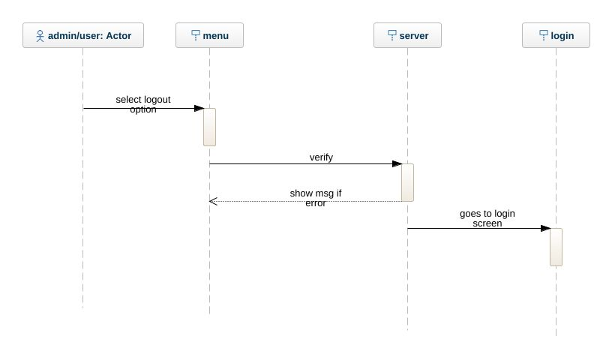

9. manage category
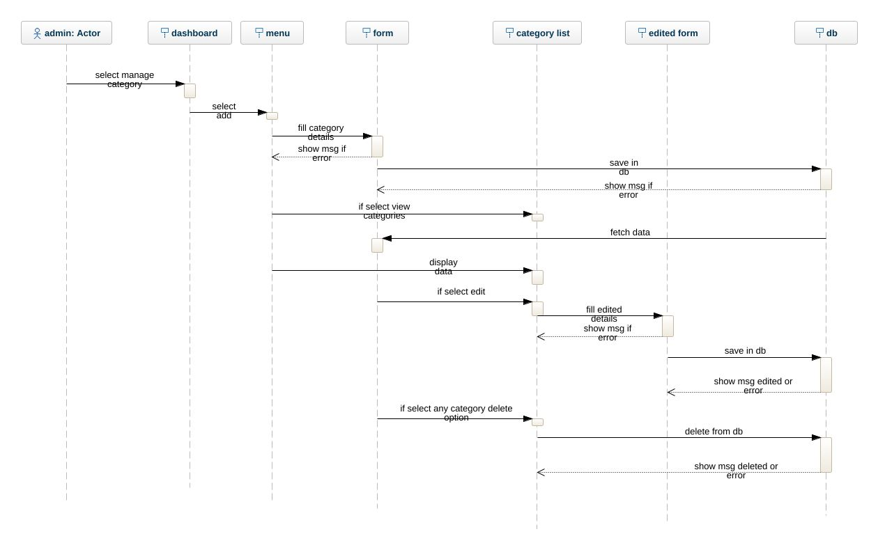
10. manage product
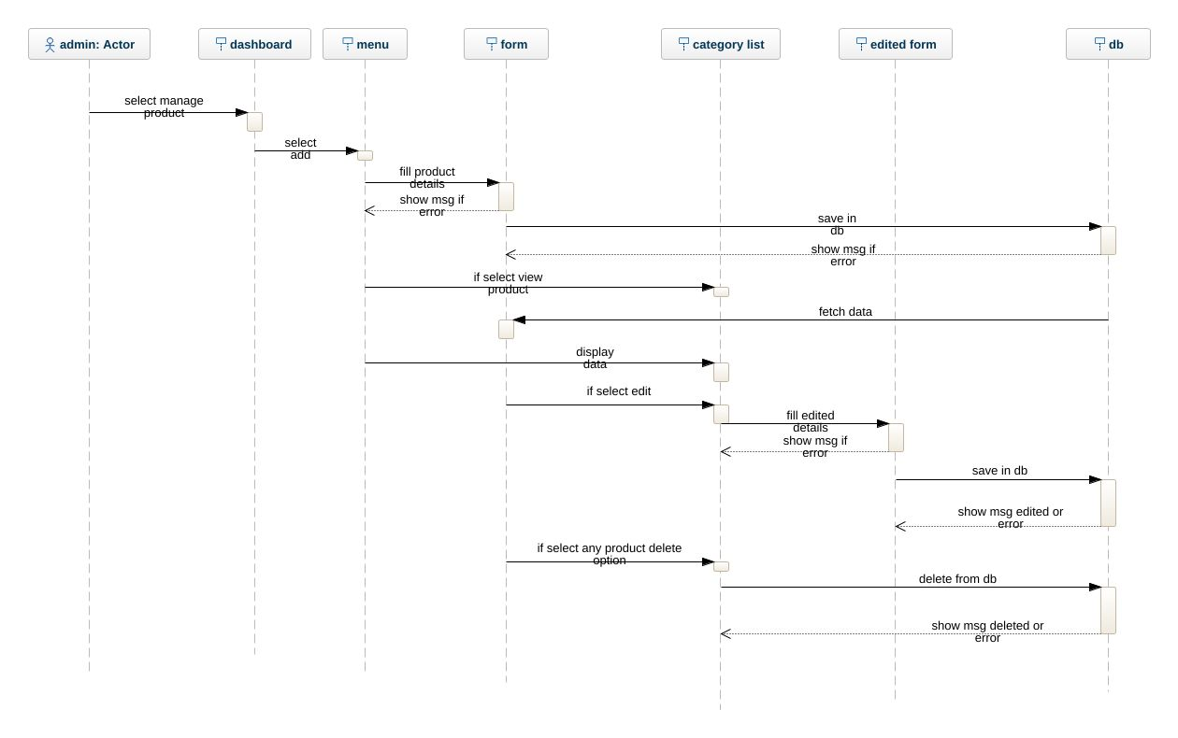

11. view orders
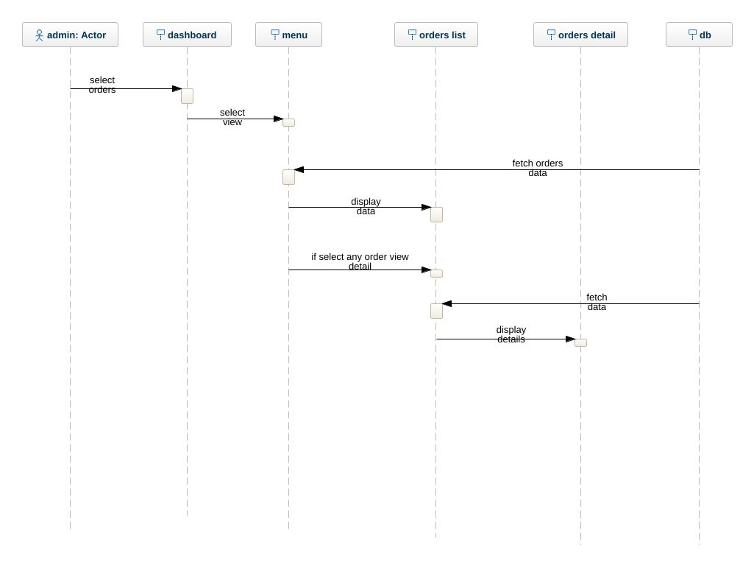

  - Object Model/Logical Model: Class Diagram

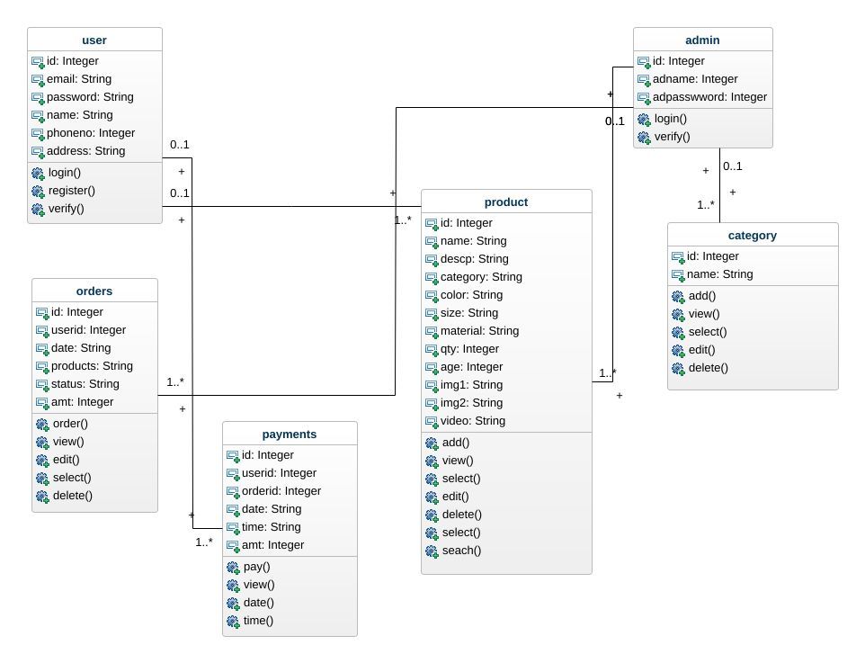

  - Database Model (Database Diagram)

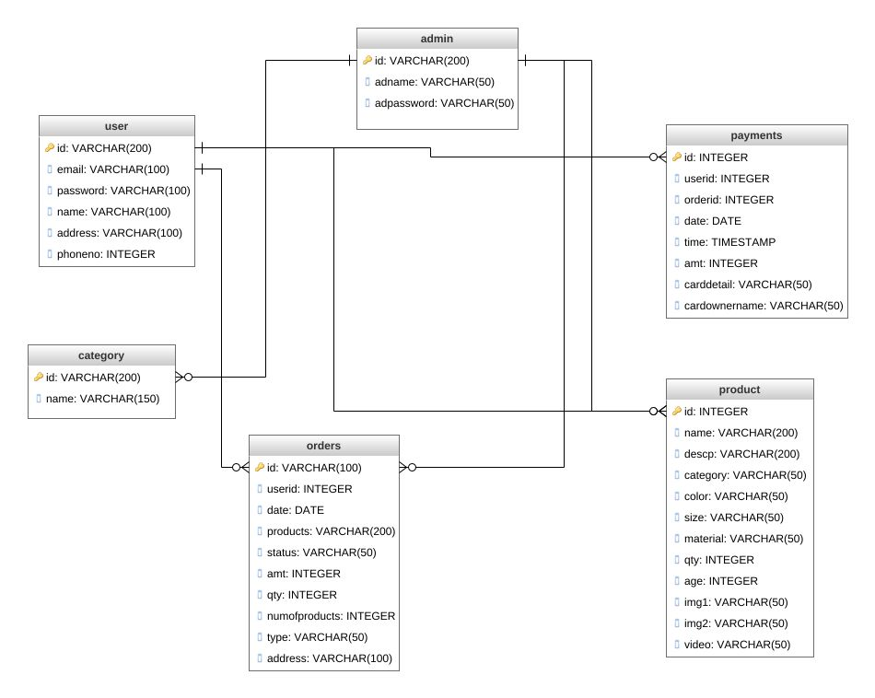

CHAPTER 4
Development

4.1 Development plan (Architecture Diagram)

REFERENCES

[1] History of PHP - Manual. (2019). Retrieved from:
https://www.php.net/manual/en/history.php
[accessed: 17 May 2019].
[2] ASP.NET Community Standup. (2019). Retrieved
from: https://live.asp.net/ , [accessed: 19 May
2019].
[3] Comentum Corp. (2010, August 1). PHP vs ASP.net
Comparison. Retrieved from:
https://www.comentum.com/php-vs-asp.net-
comparison.html , [accessed: 10 March 2019].
[4] Sebesta, R. W. (2015). Programming the World Wide
Web 8th edition. Boston: Addison-Wesley.
[5] ASP.NET and PHP Support. (2019, January).
Retrieved from:
https://www.iis.net/overview/choice/aspnetandphpsup
port [accessed: 03 June 2019].
[6] Naim, R., Nizam, M. F., Hanamasagar, S.,
Noureddine, J., & Miladinova, M. (2010).
Comparative Studies of 10 Programming Languages
within 10 Diverse Criteria. Artigo publicado no
COMP, Montreal-QC, Canadá. Montreal.
[7] Total number of Websites. (2018). Retrieved from:
https://www.internetlivestats.com/total-number-of-
websites/. , [accessed: 05 June 2019].

APPENDIX

CSS Cascading Style Sheets: Without CSS, the web would be a lot more boring. CSS is a language of rules that affect the style of HTML content. When a website uses consistent colors, fonts, and layouts across multiple web pages, this was accomplished with CSS. It’s like the icing on top of a cake built with HTML.

HTML Hypertext Markup Language: This is the first part of front-end development that many people know the basics of. Even if you aren’t technical, you may have used HTML to edit an email layout or change the text on a web page.

CRUD Create, Read, Update, Delete: If someone is learning how to build a CRUD app, they aren’t learning how to build a terrible one. They’re learning how to build an app that completes these four basic functions.

PHP Originally Personal Home Page, but renamed to PHP Hypertext Preprocessor: PHP is a common free and open-source script language used in web development.

